ICT50715
Maths Quiz Application

Student: Stuart Mackenzie
Date: 25-05-2018

Unit: ICT50715
Teacher: Mark O’Reilly

Contents

IPO Chart 3
TOE Chart 6
Stylised Data Flow 6
Selected Pseudo Code 7
Opening program. 7
Running Server. 7
Running MathsQuiz 7
Running Student 7
Exiting the program 7
Class diagram 9
User Manual for: MathsQuiz 12

IPO Chart
For Instructor

Input | Process | Output | Storage
- Running the program | - Open NetBeans  - File  - Add existing project  - Select maths quiz  - Click ok | - Showing the files and code | Temporary storage in RAM memory
- Connecting to the server | - Right click on the chat server file  - Look for the option run file  - Left click on run file  - then its connected | saying its waiting for people to join the server | Temporary storage in RAM memory
- Running the Instructor file | - Right Click on the Maths Quiz file  - Look for the option run file  - Left click on run file  - Then it is connected to the server | Should the instructor interface for the teacher | Temporary storage in RAM memory
Connecting the instructor to the server | - Get the Maths Quiz interface up  - Look for a button call connect  - Click on the button called connect  - Then the Maths Quiz is connected to server | Successfully connected to the server | Temporary storage in RAM memory
Entering a sum | - Click on the text box what is next to First Number  - Enter a number of your choosing  - Then choose your operator  - Then click on the text box next to Second Number  - Enter a number of your choosing  - Then click into the answer box  - The program will automatically do the sum | The sum you have entered  Should show | Temporary storage in RAM memory
Sending it to the student | - Once the sum was enter and the program has enter the answer for you.  - Click the send button  - The send button will send the sum not the answer to the student interface  - Then it’s the students job to enter the sum correctly

IPO Chart For the student

Input | Process | Output | Storage
- Running the student file | - Right Click on the Student file  - Look for the option run file  - Left click on run file  - Then it is connected to the server | Should the instructor interface for the teacher | Temporary storage in RAM memory
To connect the student to the server | - Get the student interface up  - Look for a button  - Call connects  - Click on the connect button  - Then the student should be connected to the server | Successfully connected to the server | Temporary storage in RAM memory
Answering the sum | - Click in the text box next to where it says answer  - Enter what you think is the correct answer  - Click send  - If the answer is wrong there is going to be a message popping  - Answer  - Then keep doing the above over and over until you get the correct answer  - If you get the correct answer and you have pressed send  - Message should pop up saying Correct  - Then you have successfully answer the sum |  | Temporary storage in RAM memory

TOE Chart

Task | Object | Event
Load up program | File | Open
Run the chat server  Run Maths Quiz | File  File | Click  Click
Run Student | File | Click
Click Connect button on Maths Quiz | Connect button | Click
Click the connect button on student | Connect button | Click
Enter sum on Maths Quiz | form | Click
Click send on Maths Quiz to send to student | Connect button | Click
Enter Answer on student until the correct answer but make sure you click send each time as the program will tell if the answer is right or wrong | send button | Click
Exit program when finishing using it | Exit button | Click

Selected Pseudo Code

Opening program.

Open up NetBeans once NetBeans is open click on file then open recent project locate the Maths Quiz program on your computer

Running Server.
Look for a file call the chat server
Once you have located the file right click on the file. There should be a whole lot of option there for you to choose from but you are looking for a option called Run file this will allow you to run the chat server file.

Running MathsQuiz
Then right click on the MathsQuiz File
Look for the opinion to Run File
Click Run file
The Interface is going to pop up on screen
Then you can connect it by hitting the connect button on
The interface but
Enter a sum
Don’t click send until you have connected the student to the server read the next section to find out how
Once you got the student file up and running and its connected to the server then you may click send to send the sum to student

Running Student

Locate file called Student
Then right click on student
Click on run file
The interface is going to put up
Connect to server
Wait until teacher has sent you a sum
Answer the sum until you get the correct answer
Keep clicking send as the program will tell you that you
That you have either got the correct answer or the incorrect answer

Exiting the program

Once you have finish using the program
Then you can simply click the exit button as
You would if closing a web browser
And the same for closing NetBeans

User Manual for: MathsQuiz
Prepared for: Mark O’Reilly
Author: Stuart Mackenzie
Date Prepared: 25-05-2018
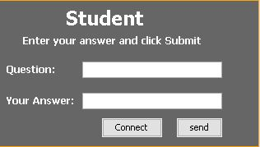 | Features by Component/Button  Screen opens: Question, Your Answer  Connect button: Connects to server  Send button: Ends Answer but to instructor
How Do I?  Send Your Answer  - Enter your Answer  - Its either right or wrong keep answering until a message pops up with Correct  - Then click send that the sum is send back to the Instructor | How Do I?  Connect to the server  - Click on connect  - Look at the button of NetBeans and it should say successfully connected to the server

Prepared for: Mark O’Reilly
Author: Stuart Mackenzie
Date Prepared: 25-05-2018
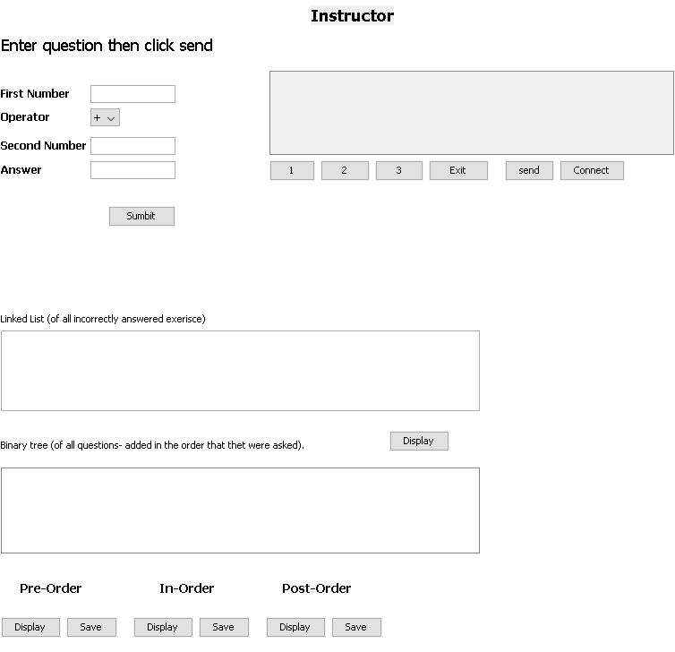 | Features by Component/Button  Screen opens: First Number Operator Second Number Answer  Connect button: Connects to server  Send button: sends Question to student  Exit button Exit Instructor interface  Submit button Sends the sum and answer to the Binary tree box
How Do I?  Connect to the Instructor to server  - Click connect button  - Look at the button of NetBeans there should be a message saying successfully connected to server | How Do I?  Exit the instructor interface  - Click on the exit button  - Then the interface will close on you

DEBUGGING

